# **Advanced Network Engineering (re-sit)**

**Part 1**

1. Explain with reference to a Wireshark packet trace, what happens when you Ping a PC on the same subnet with a packet size of 2500 Bytes and what the purpose of command ping –f and ping –i switch? (5 marks)

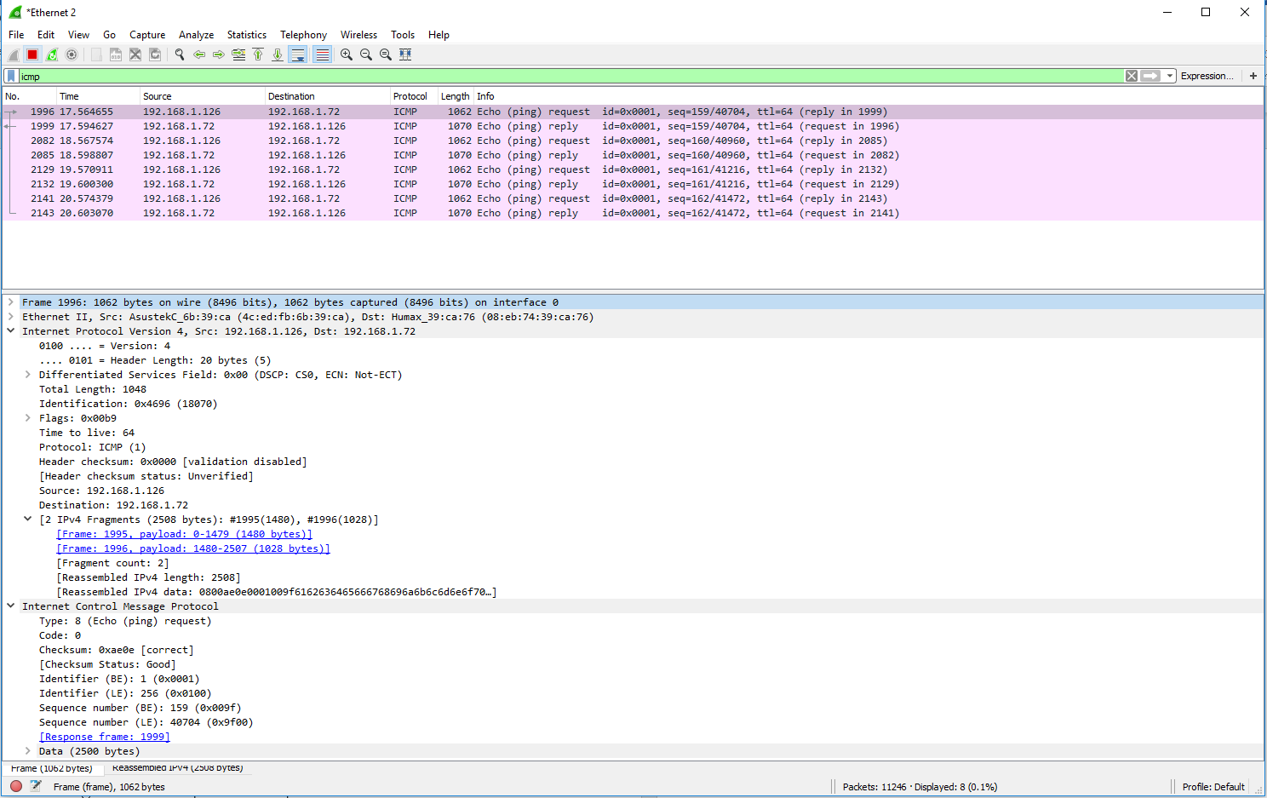

The purpose of the -f switch for ping is to set a do not fragment flag in the packet header. The purpose of the -i switch is to set a time to live on the packet.

1. The Fluke MicroScanner cable tester gave an out of spec result of 110m for the length of the cable between a bench socket 28 and the hub room. If the incorrect NVP setting was 74% and the actual cable length is 96m, calculate the correct NVP value needed to calibrate the instrument. (5 marks)

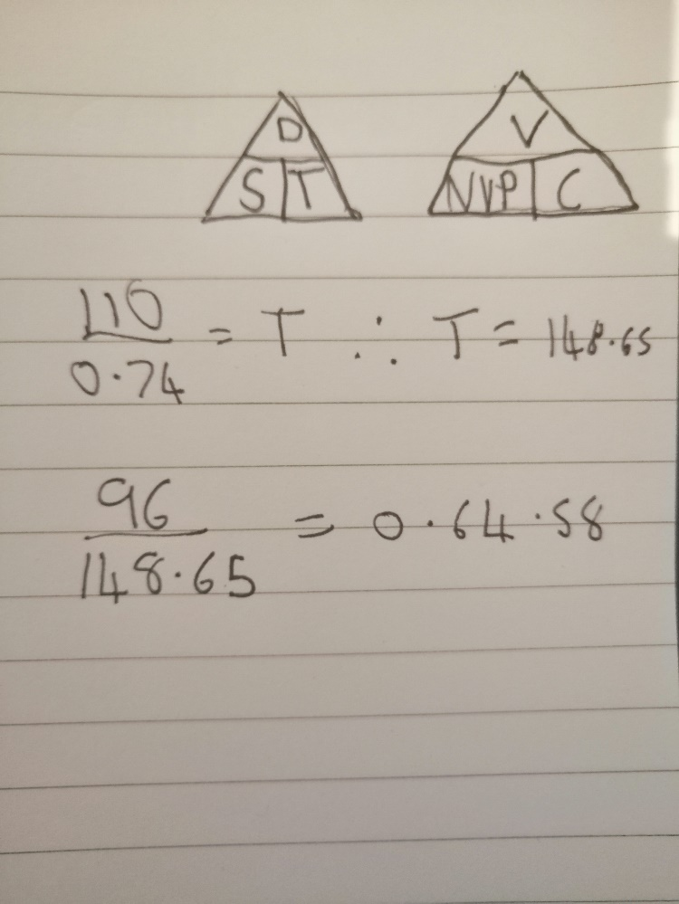

1. Submit a screen shot of the *CPUtest_xl* log file showing the %Processor Time and processor Queue Length counter as an Excel graph as described in lab1a Part c(ii) 7.

Explain and show your work how *Performance Console* was used to display a message on screen when processor activity exceeded a threshold value of 75%. Include screenshots of the message and application log for this event. (10 marks)

1. Discuss the theoretical reasons for employing Jumbo frames in the big file download scenarios and account for any unexpected results you obtained in practice.

Submit Wireshark results to show that Jumbo frames were actually being used and explain why ping <ip> -l 2500 -f does not cause frame fragmentation when Jumbo frames are transmitted. (5 marks)

1. In WLAN, calculate the power level in nW received by your network adapter and the noise level in dBm for a RSSI of -30dBm and S/N of 50dB (show your working). (5 marks)
2. With an aid of diagrams, discuss what are the difference between IEEE 802.11 WLAN and IEEE 802.3 Ethernet frame structure. (5 marks)
3. Calculate the theoretical minimum time to transfer a 100MB file over a TI WAN link using FTP and explain why it may take much longer in practice and why upgrading to a T3 service may not improve throughput very much for a long-distance link. (5 marks)
4. Submit a comparison graph showing the results you obtained for the Riverbed Modeler TCP window size optimisation simulation lab for the file transfer over a T1and T3 link for default 8KB window size and when the window size is increased to 65KB. (5 marks)
5. Discuss, why benchmarking of network components is important when designing an enterprise network. (5 marks)

**Part 2**

Build and configure a smart home implementation using Cisco Packet Tracer version 7.1 or above.

The smart home includes, but is not limited to the following smart devices:

* Ceiling Fan
* Lamp
* Front Door Lock
* Motion Detector
* Power Meter
* Lawn Sprinkler System
* Smoke Detector
* Temperature Monitor
* Thermostat
* Solar Panel

These devices are linked to a Wireless Router, which is linked via an Ethernet cable to a Cable Modem. The modem is connected to the Internet via an ISP known as SHU-LTD. All the devices registered on the Remote Server can be controlled locally by a Tablet which is also connected to the wireless network.

Prepare a report that includes the rationale of your design, and evidence obtained together with suitable commentary and annotations on the figures. All screenshots for each step with a brief explanation must be included in the document. Create a zip file that includes the report and the Packet Tracer file you have created and upload these to the Blackboard site using the link within Reassessment. Name your file using the convention **Your_Name_studentID.zip**. (50 marks)

**Assessment Criteria**

|  |  |
| --- | --- |
| 40% - 50% | Demonstrates basic knowledge largely based on the lecture notes and lab sheets.  Technique lacking when performing interpretation of concepts and presenting data. |
| 50% - 60% | Demonstrates knowledge based on taught material interpretation shows good knowledge of the subject.  Appropriate techniques and tools used to obtain and analyse lab results. |
| 60% - 70% | Demonstrates some knowledge beyond taught material interpretation of source demonstrates good knowledge of the subject.  Good technique used in most aspects of lab work and results analysis and presentation. |
| +70% | Demonstrates knowledge beyond taught material with good interpretation of taught and sourced material.  Good technique in all aspects of lab work reporting and analysis and presentation. |